**Exercise 1: Mocking and Stubbing**

**ExternalApi.java**

public interface ExternalApi {

String getData();

}

**MyService.java**

public class MyService {

private ExternalApi api;

public MyService(ExternalApi api) {

this.api = api;

}

public String fetchData() {

return api.getData();

}

}

**pom.xml**

<dependencies>

<dependency>

<groupId>org.mockito</groupId>

<artifactId>mockito-core</artifactId>

<version>4.11.0</version>

<scope>test</scope>

</dependency>

<dependency>

<groupId>org.junit.jupiter</groupId>

<artifactId>junit-jupiter</artifactId>

<version>5.9.3</version>

<scope>test</scope>

</dependency>

</dependencies>

**MyServiceTest.java**

import static org.mockito.Mockito.*;

import static org.junit.jupiter.api.Assertions.*;

import org.junit.jupiter.api.Test;

import org.mockito.Mockito;

public class MyServiceTest {

@Test

public void testExternalApi() {

ExternalApi mockApi = Mockito.mock(ExternalApi.class);

when(mockApi.getData()).thenReturn("Mock Data");

MyService service = new MyService(mockApi);

String result = service.fetchData();

assertEquals("Mock Data", result);

System.out.println("Mock returned: " + result);

}

}

**Output:**

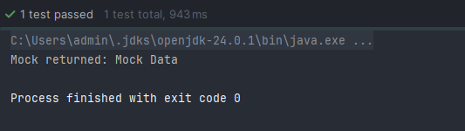

**Exercise 2: Verifying Interactions**

**ExternalApi.java**

public interface ExternalApi {

String getData();

}

**MyService.java**

public class MyService {

private ExternalApi api;

public MyService(ExternalApi api) {

this.api = api;

}

public String fetchData() {

return api.getData();

}

}

**pom.xml**

<dependency>

<groupId>org.mockito</groupId>

<artifactId>mockito-core</artifactId>

<version>4.11.0</version>

<scope>test</scope>

</dependency>

<dependency>

<groupId>org.junit.jupiter</groupId>

<artifactId>junit-jupiter</artifactId>

<version>5.9.3</version>

<scope>test</scope>

</dependency>

**MyServiceTest.java**

import static org.mockito.Mockito.*;

import static org.junit.jupiter.api.Assertions.*;

import org.junit.jupiter.api.Test;

import org.mockito.Mockito;

public class MyServiceTest {

@Test

public void testVerifyInteraction() {

ExternalApi mockApi = Mockito.mock(ExternalApi.class);

when(mockApi.getData()).thenReturn("Mock Response");

MyService service = new MyService(mockApi);

String result = service.fetchData();

assertEquals("Mock Response", result);

verify(mockApi, times(1)).getData();

System.out.println("Mock returned: " + result);

System.out.println("Interaction verified with mock API.");

}

}

**Output:**

